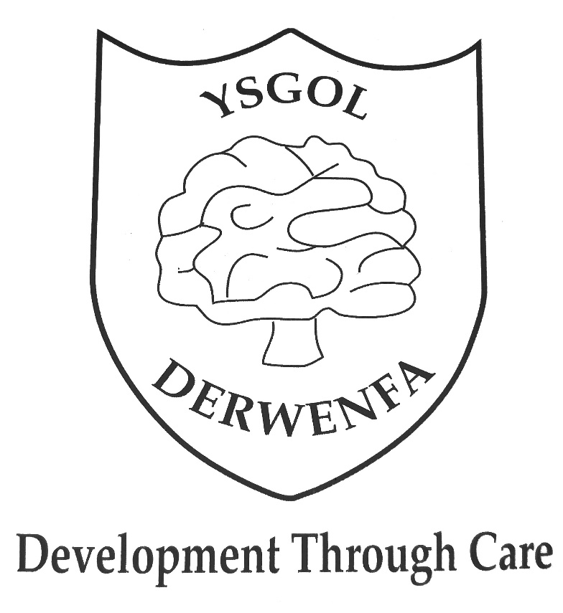

Freedom of Information
Policy

Adopted: April 2021

Freedom of Information Policy
The aim of this policy is to ensure that Ysgol Derwenfa is compliant with its obligations under the Freedom of Information Act 2000 (FOIA). It is the responsibility of the Governors to ensure procedures are in place and to ensure that Ysgol Derwenfa handles information requests covered by the Freedom of Information Act, the Data Protection Act 2018, the General Data Protection Regulation 2016/679 and the Environmental Information Regulation 2004 (EIR), in accordance with the provisions laid out therein, and that Ysgol Derwenfa satisfies the standards set out in the Lord Chancellor’s Code of Practice on satisfying public authorities obligations under FOIA, produced under Section 45 of that Act.
________________________________________________________________________
Introduction
Ysgol Derwenfa is committed to the Freedom of Information Act 2000 (FOI), to the principles of accountability and to the general right of access to information held by Ysgol Derwenfa, subject to the exemptions contained within the relevant legislation. The FOI Act was introduced to promote greater openness and accountability across the public sector. The Information Commissioner’s Office (ICO) is responsible for regulating and enforcing the Act. The ICO is an independent authority which has legal powers to ensure schools comply with the Act. This policy outlines Ysgol Derwenfa responsibilities to the Act and provides a framework for managing requests.
Background
The FOIA provides the public with a statutory right of access to recorded information held by Ysgol Derwenfa, subject to certain exemptions, within 20 working days. The Act is fully retrospective and applies to all information that falls within the scope of the Act. Section 19 of the Act also obliges Ysgol Derwenfa to make information pro-actively available in the form of an approved publication scheme. In addition, individuals currently have a statutory right of access to their own personal data under the Data Protection Act. Individuals access rights to personal data are extended by the FOIA through amendments to the access provisions of the Data Protection Act. The Environmental Information Regulation (EIR) provides a statutory right of access to ‘environmental information’, as defined in these Regulations. The EIR are also fully retrospective. The Information Commissioner enforces these three information regimes. Each regime contains certain categories of exempt information, where information can be withheld. Any decision to withhold information under an exemption can be referred by the applicant to the Information Commissioner, who can overturn any decision to withhold information. For the purposes of this policy, the public is defined as any individual or organisation anywhere in the world and an information request refers to any request for recorded information made under the FOIA, EIR or DPA.
Scope
This policy applies to all recorded information held by Ysgol Derwenfa that relates to the business of Ysgol Derwenfa. This includes:
- Information created and held by Ysgol Derwenfa
- Information created by Ysgol Derwenfa and held by another organisation on Ysgol Derwenfa behalf
- Information held by Ysgol Derwenfa provided by third parties, where this relates to a function or business of Ysgol Derwenfa (such as contractual information)
- Information held by Ysgol Derwenfa relating to Governors where the information relates to the functions or business of Ysgol Derwenfa.
This policy informs recipients of school services, members of the public and external parties to the processes Ysgol Derwenfa has established for complying with the FOIA. This policy operationally applies to all employees of Ysgol Derwenfa, governors, contractors, agents and temporary staff working for or on behalf of Ysgol Derwenfa. This policy does not cover personal written communications (such as personal e-mails sent by staff). Data Protection Policy establishes the standards regarding the use of ‘personal data’ (as defined in the DPA and General Data Protection Regulation). These requests are exempt for the FOIA under section 40 and shall be processed in accordance with the Data Protection Act 2018 (DPA).
Roles and Responsibilities
Overall responsibility for ensuring that Ysgol Derwenfa meets the statutory requirements of the FOIA, EIR and DPA lies with the Governors and the Chair of Governors has overall responsibility for information management issues. They have delegated the day-to-day responsibility of implementation to the Headteacher (Mr.Andrew Jones). The Headteacher and Senior Management are required to ensure that Ysgol Derwenfa have in place adequate guidance on FOIA and effective measures to comply with this policy. All employees are responsible for ensuring that any request for information they receive is dealt with in line with the requirements of the FOIA and in compliance with this policy and the prevailing procedures. All staff must recognise that all recorded information may be provided to the public, and that the law requires that there will be full and unconditional disclosure to every case unless an exemption applies. Ysgol Derwenfa Data Protection Officer has responsibility for ensuring compliance with the FOIA, EIR and DPA. All requests for information should be sent to the Headteacher (lemail@hwbmail.net). Third parties who are users of information supplied by Ysgol Derwenfa will be required to confirm that they will abide by the requirements of the FOIA and indemnify Ysgol Derwenfa against any prosecutions, claims, proceedings, actions or payment of compensation or damages, without limitation
Ysgol Derwenfa will ensure that:
- Everyone managing, and handling information understands that they are responsible for following good information management practice
- Staff who handle information are appropriately supervised and trained
- Methods of handling information are regularly assessed and evaluated
- Any disclosure of data will be in compliance with approved procedures
- All necessary steps will be taken to ensure that data is kept secure at all times against unauthorised or unlawful loss or disclosure
- All contractors who are users of information supplied by Ysgol Derwenfa will be required to confirm that they will comply with the requirements of the Act with regard to information supplied by Ysgol Derwenfa
- Ysgol Derwenfa will abide by any Code of Practice on the discharge of the functions of Public authorities with is issued by the Ministry of Justice
In addition, Ysgol Derwenfa will take account of any guidance which is issued by the Information Commissioner to promote good practice.
Principles
The following principles shall apply:
- The Act covers any recorded information held by Ysgol Derwenfa. Recorded information includes printed documents, computer files, letters, emails, photographs, and sound or video recordings
- People shall have a right to know about the activities of Ysgol Derwenfa, unless there is a good reason for them not to
- An applicant (requester) shall not be required to provide a reason for requesting information. Ysgol Derwenfa shall however justify refusing a request
- Ysgol Derwenfa shall treat all requests for information equally, except under some circumstances relating to vexatious requests and personal data
Requesting Information
Any written request for information shall be regarded as a request for recorded information under the FOI Act unless:
- It forms a request for personal data relating to the individual requesting the information. This shall be dealt with under the General Data Protection Regulation (GDPR), and consequently shall be processed in line with Ysgol Derwenfa Subject Access Request Policy
- If an individual is asking for environmental information, the request shall be considered under the Environmental Information Regulation 2004
A freedom of information request shall only be accepted if made in writing, (online forms, letters, emails, faxes and social media). Requests for information shall be met within 20 school term days of receipt and if more information is needed the 20 days will not start until this information has been received. A request for information shall not be refused because the recorded information is out of date, incomplete or inaccurate. Ysgol Derwenfa will not make any changes or deletions to records as a result of a request. Requests should be made to the Headteacher (lemail@hwbmail.net)
Refusing a Request
The FOIA Act contains 23 exemptions whereby information can be withheld. There are two categories, absolute and non-absolute. Ysgol Derwenfa will only withhold information if it falls within the scope of one or more of these exemptions. Where an absolute exemption applies, Ysgol Derwenfa can automatically withhold the information. However, where the exemption is non-absolute the information can only be withheld where Ysgol Derwenfa decides that the public interest is best served by withholding the information. Certain exemptions also contain a prejudice test, which means that the exemption can only be claimed if disclosing the information would prejudice the interest protected by the exemption. Ysgol Derwenfa will only withhold information covered by the exemption. Complete files or documents will not be withheld just because part of the information is covered by an exemption. Ysgol Derwenfa will only apply an exemption where it has reason to believe that prejudice might occur to the interest protected by the exemption. In addition, wherever a public interest exemption is being considered, Ysgol Derwenfa will only withhold that information which it can demonstrate that the public interest will be best served by withholding. When considering withholding information under a non-absolute exemption Ysgol Derwenfa will consider whether the release of the information would:

- Promote further understanding of current issues of public debate
- Promote the accountability of decisions taken by Ysgol Derwenfa and the spending and allocation of public money
- Bring to light matters of public safety
- Allows the public to understand and challenge decisions made by Ysgol Derwenfa
- Be otherwise in the public interest where information is withheld under an exemption
In most cases the reason behind the decision will be made clear to the applicant, citing the exemption under which the information is being withheld. The applicant will also be given details of the right to challenge the decision through Ysgol Derwenfa Governing Body and the right of appeal to the Information Commissioner’s Office. Ysgol Derwenfa will also refuse to supply information under the FOIA, where the request is considered vexatious or repeated and under the EIR, where the request is considered manifestly unreasonable.
Third Party Information
The release of third-party information will be considered carefully to prevent actions for breach of confidence or, in the case of living individuals, breaches of the DPA and/or GDPR. Both the EIR and FOIA permit information to be withheld when its release would breach the provisions of the DPA and/or GDPR. When the requested information relates to a living individuals personal data as defined in the DPA/GDPR, its disclosure could breach. Therefore, the release of third-party personal information relating to living individuals will be considered in accordance with the data protection principles and, in particular, the third-party provisions of the DPA/GDPR. Ysgol Derwenfa will endeavour to inform individuals and organisations submitting information that the information might be released following an information request and, where appropriate, will provide the supplier of the information opportunity to request confidentiality or supply reasons as to why the information should be treated confidentially.
Information Held Within Contracts
Any contractual information, or information obtained from organisations during the tendering process, held by Ysgol Derwenfa are subject to the provisions of the FOIA and EIR. Whenever Ysgol Derwenfa enters into contracts, it will seek to exclude contractual terms forbidding the disclosure of information beyond the restrictions contained in the legislation. A standard form of wording will be included in contracts to cover the impact of FOIA and EIR in relation to the provision of information held in contracts. Ysgol Derwenfa can withhold contractual information where its disclosure under either the FOIA or EIR could be treated as actionable breach of confidence. Where Ysgol Derwenfa intends to include non-disclosure provisions in a contract, it will agree with the contractor a schedule of the contract that clearly states which information should not be disclosed. Ysgol Derwenfa will only agree to enter into confidentiality clauses where the information is confidential in nature and that it is confident that the decision to restrict access to the information could be justified to the Information Commissioner. Where information is not covered by the exemption relating to information accepted in confidence, a further exemption specifically under FOIA may be relevant, relating to commercial interests. This exemption is subject to a public interest test. Whenever Ysgol Derwenfa has to consider the release of such information, it will contact the relevant organisation to obtain its opinions on the release of the information and any exemptions they may think relevant. However, Ysgol Derwenfa will make the final decision relating to the disclosure of the information. Ysgol Derwenfa can also withhold information contained in contracts where any of the other exemptions listed in the FOIA or EIR are appropriate. All future contracts should contain a clause obliging contractors to co-operate fully and in a timely manner where assistance is requested in responding to an FOIA or EIR request.
Publishing Information
Ysgol Derwenfa information will be published on their website via a publication scheme. It is the responsibility of the Headteacher and the local governing body to ensure that the information covered by this scheme is routinely available. In exceptional circumstances some information may be available only by viewing in person. An appointment to view the information will be arranged within a reasonable timescale. Ysgol Derwenfa shall make a disclosure log available on their website that sets out responses to previous FOI requests.
Charges
Ysgol Derwenfa will make no initial charges for making a FOI request. In some cases, where a request is manifestly unfounded, Ysgol Derwenfa shall charge an appropriate fee for complying with the request. The fee will be to cover administrative costs of the staff. If a charge is to be made, confirmation of the payment due will be given before the information is provided. Payment may be requested prior to provision of the information.
Review Requests
Ysgol Derwenfa shall carryout a review of a request whenever the requestor expresses dissatisfaction with the outcome. This request should be made within 20 working days of receipt to Ysgol Derwenfa response and the requester should set out what they are not satisfied with. Ysgol Derwenfa shall conduct a review within 20 working days. If the requester is not happy with the outcome of the review, they have the right to apply directly to the Information Commissioner for a decision. The Information Commissioner can be contacted at: Information Commissioner’s Office Wycliffe House Water Lane Wilmslow Cheshire SK95AF Tel: 0303 123 1113 www.ico.org.uk

