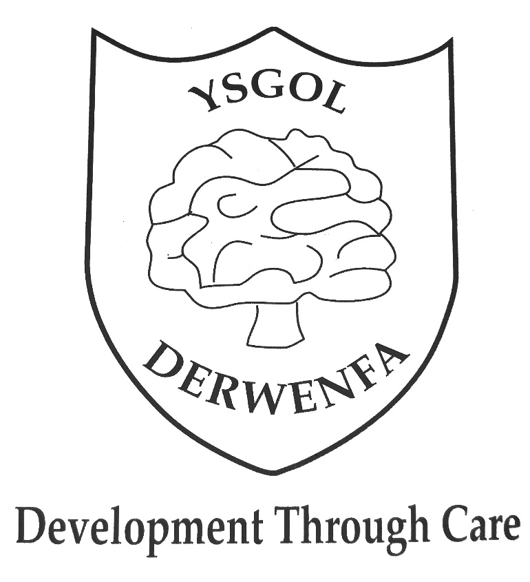

Freedom of Information Publication Scheme

Adopted: April 2021

Freedom of Information Publication Scheme
The governing body is responsible for maintenance of this scheme, which was updated in April 2021 and approved by the governing body in June 2021
Introduction
- This publication scheme commits Ysgol Derwenfa to make information available to the public as part of its normal business activities. The information covered is included in the classes of information mentioned below, where this information is held by Ysgol Derwenfa. The scheme commits Ysgol Derwenfa:
- To proactively publish or otherwise make available as a matter of routine, information, including environmental information, which is held by the school and falls within the classifications below
- To specify the information which is held by the school and falls within the classifications below
- To proactively publish or otherwise make available as a matter of routine, information in line with the statements contained within this scheme
- To produce and publish the methods by which the specific information is made routinely available so that it can be easily identified and accessed by members of the public
- To review and update on a regular basis the information the school makes available under this scheme
- To produce a schedule of any fees charged for access to information which is made proactively available
- To make this publication scheme available to the public
Classes of information
The following documents can be made available from the school:
- School Prospectus
- Policies
- School sessions, curriculum and dates
- School Governance – terms of reference and names of governors
- Instrument of governors
- Staffing list and responsibilities
- Location and contact information
What we spend and how we spend it
- Annual budget plan and financial statements
- 1-year financial plan
- EIG and PDG grant spending
- School fund statements and audit certificates yearly
- Procurement and contracts
- Whole School Pay Policy
- Financial management policies
- Parents Association monies raised and spend
What our priorities are and how we are doing
- School Improvement Plan
- Latest Estyn Inspection report
- Performance management Policy
- Safe-guarding and child protection policy
- Health and Safety and fire risk assessment reports
- Behaviour Policy
- Site facilities audit
- Equality and Inclusion Policy

How we make decisions
- Maintained school admission policy
- SLT meetings/staff meetings
- Minutes from Governors meetings (part 1 only)

Our policies and procedures
- Attendance
- Admissions
- Additional Learning Needs
- Anti-bullying
- Assessment
- Behaviour
- Calculations
- Charging
- Child protection
- Collective worship
- Complaints
- Data protection
- DBS checks
- Drugs and Alcohol
- Foundation Phase Policy
- Equality and plan
- Financial policies
- Administration of medicines
- Freedom of Information
- Grievance Policy
- Handwriting and presentation
- Health and Safety
- Homework
- Home School Agreement
- Internet Acceptable Use
- ICT Policy
- Literacy
- Lone worker
- Marking and feedback
- Mathematics
- Disability
- Monitoring and evaluation
- Music
- Performance management
- Physical education
- Physical restraint
- Race equality
- Risk assessment
- Safer recruitment
- Sex and relationships
- School security
- Science
- Special Educational needs
- Staff information handbook
- Target setting
- Teacher capability
- Toileting
- Use of images
- Visits
- Code of conduct for Parents
- Whistleblowing
Lists and registers
- Asset register
- Asbestos register
- Any other information the school is legally required to hold in publicly available registers
- Instrument of governance
- Register of Governors
The services we offer
All information on our service can be found in the prospectus, Information packs and on the school website. Newsletters are sent out once a month. Information is e-mailed regularly to parents. We have a text messaging service. The school provides 8.15am breakfast club on site and 3.15 – 5.15 pm care.
The classes of information will not generally include:
- Information the disclosure of which is prevented by law, or exempt under the Freedom of Information Act, or is otherwise properly considered to be protected from disclosure
- Information in draft form.
- Information that is no longer readily available as it is contained in files that have been placed in archive storage, or is difficult to access for similar reasons

The method by which information published under this scheme will be made available. The school will indicate clearly to the public what information is covered by this scheme and how it can be obtained. Where it is within the capability of the school, information will be provided on our website. Where it is impracticable to make information available on a website or when an individual does not wish to access the information by the website, we will indicate how information can be obtained by other means and provide it by those means. In exceptional circumstances, some information may be available only by viewing in person. Where this manner is specified, contact details will be provided. An appointment to view the information will be arranged within a reasonable timescale. Information will be provided in the language in which it is held or in such other language that is legally required. Where an authority is legally required to translate any information, it will do so. Obligations under disability and discrimination legislation and any other legislation to provide information in other forms and formats will be adhered to when providing information in accordance with this scheme.
Charges which may be made for information published under this scheme. The purpose of this scheme is to make the maximum amount of information readily available at minimum inconvenience and cost to the public. Charges made by the school for routinely published material will be justified and transparent and kept to a minimum. Material which is published and accessed on a website will be provided free of charge. Charges may be made for information subject to a charging regime specified by Parliament. Charges may be made for actual disbursements incurred such as:
- photocopying
- postage and packaging
- the costs directly incurred as a result of viewing information
Charges may also be made for information provided under this scheme where they are legally authorised, they are in all the circumstances, including the general principles of the right of access to information held by public authorities, justified and are in accordance with a published schedule or schedules of fees which is readily available to the public. If a charge is to be made, confirmation of the payment due will be given before the information is provided. Payment may be requested prior to provision of the information.
Written requests Information held by a public authority that is not published under this scheme can be requested in writing, when its provision will be considered in accordance with the provisions of the Freedom of Information Act.
Contact details
If you require a paper version of any information or want to ask whether information is available, please contact the school by telephone, email, or letter.
Contact details are set out below.
Email: lemail@hwbmail.net
Tel: 01352 770477
Contact Address: Ysgol Derwenfa, Queen Street, Nr.Mold, Flintshire, CH5 4 PW
To help us process your request quickly, please clearly mark any correspondence “PUBLICATION SCHEME REQUEST” (in CAPITALS please) If the information you are looking for isn’t available via the scheme and isn’t on our website, you can still contact the school to ask if we have it.
Note: This model publication scheme has been prepared and approved by the Information Commissioner to be adopted without modification by any public authority without further approval and will be valid until further notice.

